Yafu, Xiao

Instructor Si, Li

ECE 110

Date November 9, 2023

Unit 1 Report

Topic 1: Resistor Network

The resistance network used has two groups of resistors in parallel. The first group consists of 7 100-ohm resistors in parallel. The second group consists of 6 100-ohm resistors and a 330-ohm resistor in parallel. For a parallel resistor network, its equivalent resistance can be calculated with the formula below:

$$\frac{1}{R_{E}}=\frac{1}{R_{1}}+…+\frac{1}{R_{n}}$$

The following graph shows the measurements we did and its comparison with the theoretical equivalent resistance value calculated using the formula above.

|  |  |  |
| --- | --- | --- |
| Group | Measured Resistance (Ω) | Theoretical Resistance (Ω) |
| Group 1 | 14.24 | 14.28 |
| Group 2 | 15.93 | 15.86 |

Figure 1: The equivalent resistance of resistor network used to control speed of motors.

We take group 1 for further analysis in rated power. We know that:

$$P=VI=\frac{V^{2}}{R}=I^{2}R$$

First, consider the equivalent resistance a true resistor. With Ohm’s law we know that with a given voltage drop, a given current runs through the resistor. When we replace it with a parallel network of larger resistors, 100-ohm resistors in this case, the voltage drop on each resistor remains the same while the current through each resistor drops. We would then be able to conduct power higher than the rated power of a single 100-ohm resistor. From the formula above and Ohm’s law, we can know that:

$$P=nP_{r}$$

Substitute the rated power of each resistor and the number of resistors in the network, we can then calculate the rated power of the network, which is 1.75 watts.

Topic 2: The efficiency, 𝜂, of the Resistor Network for Speed Control circuit

The resistor network mentioned in topic one was used for the speed control circuit on our car. For further exploration into this topic, I would use the group 1 resistor network, for it is a typical parallel resistor network consisting of 7 resistors of the same resistance.

We know that:

$$η=\frac{P_{useful}}{P_{wasted}+P_{useful}}$$

Which is in this case:

$$η=\frac{I^{2}R_{m}}{I^{2}R_{e}+I^{2}R_{m}}=\frac{R_{m}}{R_{e}+R_{m}}$$

Where Rm represents the resistance of a motor if viewed as a resistor, Re represents the equivalent resistance of the resistor network. I is the current of the circuit. The measured values are as follows:

|  |  |
| --- | --- |
| Rm | Re |
| 36.40 | 14.24 |

Figure 2: The measured values of Rm and Re.

We can then substitute all values into the function above, and we can get the numeric $η$ = 71.87%=0.7187

Topic 3: The agreement (or disagreement) of actual measurements taken to confirm Kirchhoff’s laws.

The circuit we used to do this confirm KCL and KVL is:

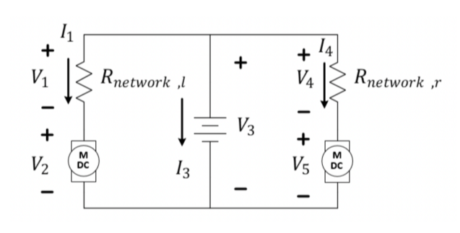

Figure 3: The KVL and KCL confirmation circuit.

The Resistor network we used consists of 5 100-ohm resistors, and the measured resistance is as follows.

|  |  |
| --- | --- |
| Group 1[Network l](Ω) | Group 2[Network r](Ω) |
| 20.06 | 19.93 |

Figure 4: The Resistance of Resistor networks in Figure 3.

The voltage drops we measured are as follows.

|  |  |  |  |  |
| --- | --- | --- | --- | --- |
| V1(V) | V2(V) | V3(V) | V4(V) | V5(V) |
| -2.7 | -4.5 | 7.5 | -2.6 | -4.5 |

Figure 5: The values of voltage drops in Figure 3.

We can then write:

$$V_{3}+V_{4}+V_{5}=V_{3}+V_{1}+V_{2}≈0$$

Considering that the errors are within tolerance, this indicates that the KVL is correct.

We then used the voltages we measured to calculate the currents, shown as follows:

|  |  |  |
| --- | --- | --- |
| I3(A) | I1(A) | I4(A) |
| 0.26 | 0.1305 | 0.1346 |

Figure 6: The values of currents in Figure 3.

We can then write:

$$I_{3}+I_{1}+I_{4}≈0$$

Considering that the errors are within tolerance, this indicates that the KCL is correct.

Topic 4: Usage of Equipment.

A typical Rigol multimeter in the laboratory has a input panel that looks like this:

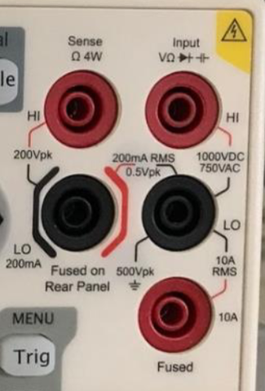

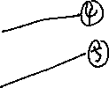

Figure 7: The input panel of a Rigol Multimeter, label mine.

When we are to use the ohmmeter function, we use ports ③ and ④ and press the Ω button. We must make sure that the resistor to be measured are in SERIES with the ohmmeter and has no external voltage or current source.

When we are to use the voltmeter function, we use ports ③ and ④, and press the DCV button. We must make sure that the components to be measured are in PARALLEL with the voltmeter and has an external voltage or current source. To get a positive value, the current from the circuit must go from the red port to the black port, but that’s not necessary since there are cases that we should measure a negative value, confirming KVL for example.

When we are to use the ammeter function, we use ports ② and ④ (small currents) and press the DCI button. We must make sure that the ammeter are in SERIES with the components in the circuit whose current is to be measured and make sure that there is a external voltage or current source.

When we are to use the Rigol power supply in the laboratory, we connect the two outputs of the power supply, and connect it into the circuit that needs power. We need to set a voltage and a maximum current value for the power supply to work. Select the channel you connected to your circuit. Press the button that has numbers beside them to set a value and press the key with a V sign beside it to set it as the maximum voltage. Do the same but press the key with an A sign beside it to set it as the maximum amperage. The power supply is by default and used as a voltage source but beware that it will not give the full voltage if the current in the circuit is larger than the maximum amperage.

When we are to use the battery, we must beware that it has no amperage limit, and it is set to provide a constant 3.8 Volts of voltage. When it’s short connected, it may melt itself, causing great trouble.

A typical Rigol oscilloscope in the laboratory looks like this:

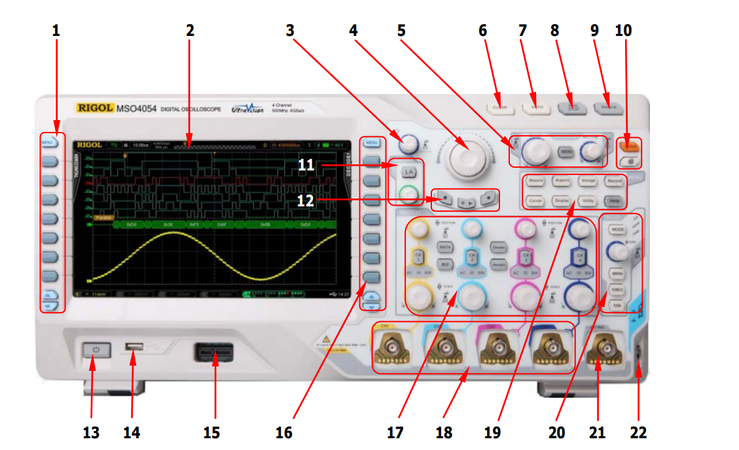

Figure 8: Oscilloscope control panel, graph from cn.rigol.com.

When we are to use the oscilloscope, we connect a BCD cable to the channel we are to use and connect the two ends of the cable in PARALLEL with the component we are to measure. We should press the channel button of the channel we are to use to start. The o-scope is by default set to Auto mode. We use button 5 to adjust the length of time displayed, in order to have a clear, not trembling wave form. For the single mode, we use it in the case where wave forms are not continuous, such as the cloud detector. We set a certain trigger value, and then the machine records the wave form between the time when voltage went higher and again lower than the triggering value for a single time. Adjust the trigger value by using the menu.

Topic 5: Modules done.

It is a shame that we only finished one module due to a failed time schedule, which is module 003, Introduction to the Arduino/RedBoard. The learning objectives of this module are learning the basic IO pins of Arduino, how to identify between different types of pins and signals, how to refer to them in the Arduino IDE and how to upload a simple program onto the Arduino board. This Module was really interesting and we learnt a lot about how to get started with Arduino.